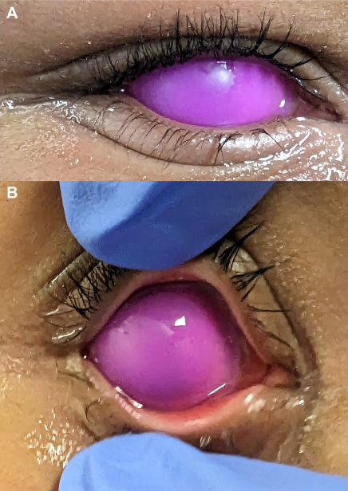

A 9-year-old girl presented with a circular popping fidget toy in her right eye. She reported getting the idea from social media. The fidgettoy was removed using jeweler’s forceps, with a second examiner holding her head still. Following the removal, fluorescein staining revealedmoderate diffuse punctate epithelial erosions, but no corneal abrasion. The patient’s family planned to communicate with the patient’steacher to ensure no other students attempted a similar act; (A) shows the toy in her eye; (B) depicts an examiner opening the eye, illustratingthe relative sizes of the toy and the eye. Based on the provided images and clinical description please make an ophthalmic diagnosis for this patient. And output the diagnostic conclusions only.

**Corneal foreign body with secondary punctate epithelial erosions.**